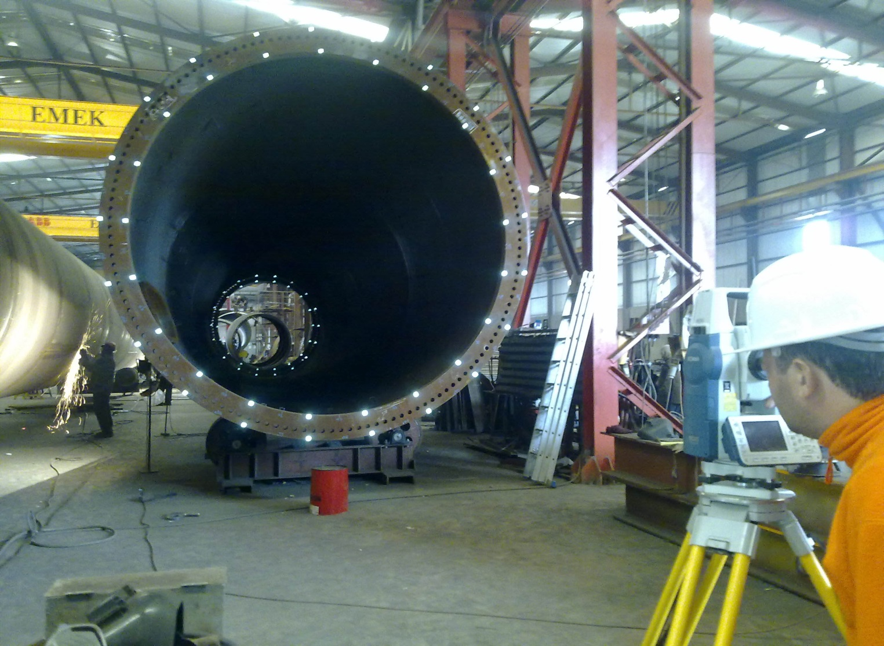

INDUSTRIAL SURVEYING

3

3

3

3

High Pressure Natural Gas and Regulating Station, Tema, Ghana

3

3

INDUSTRIAL SURVEYING

INDUSTRIAL SURVEYING

3

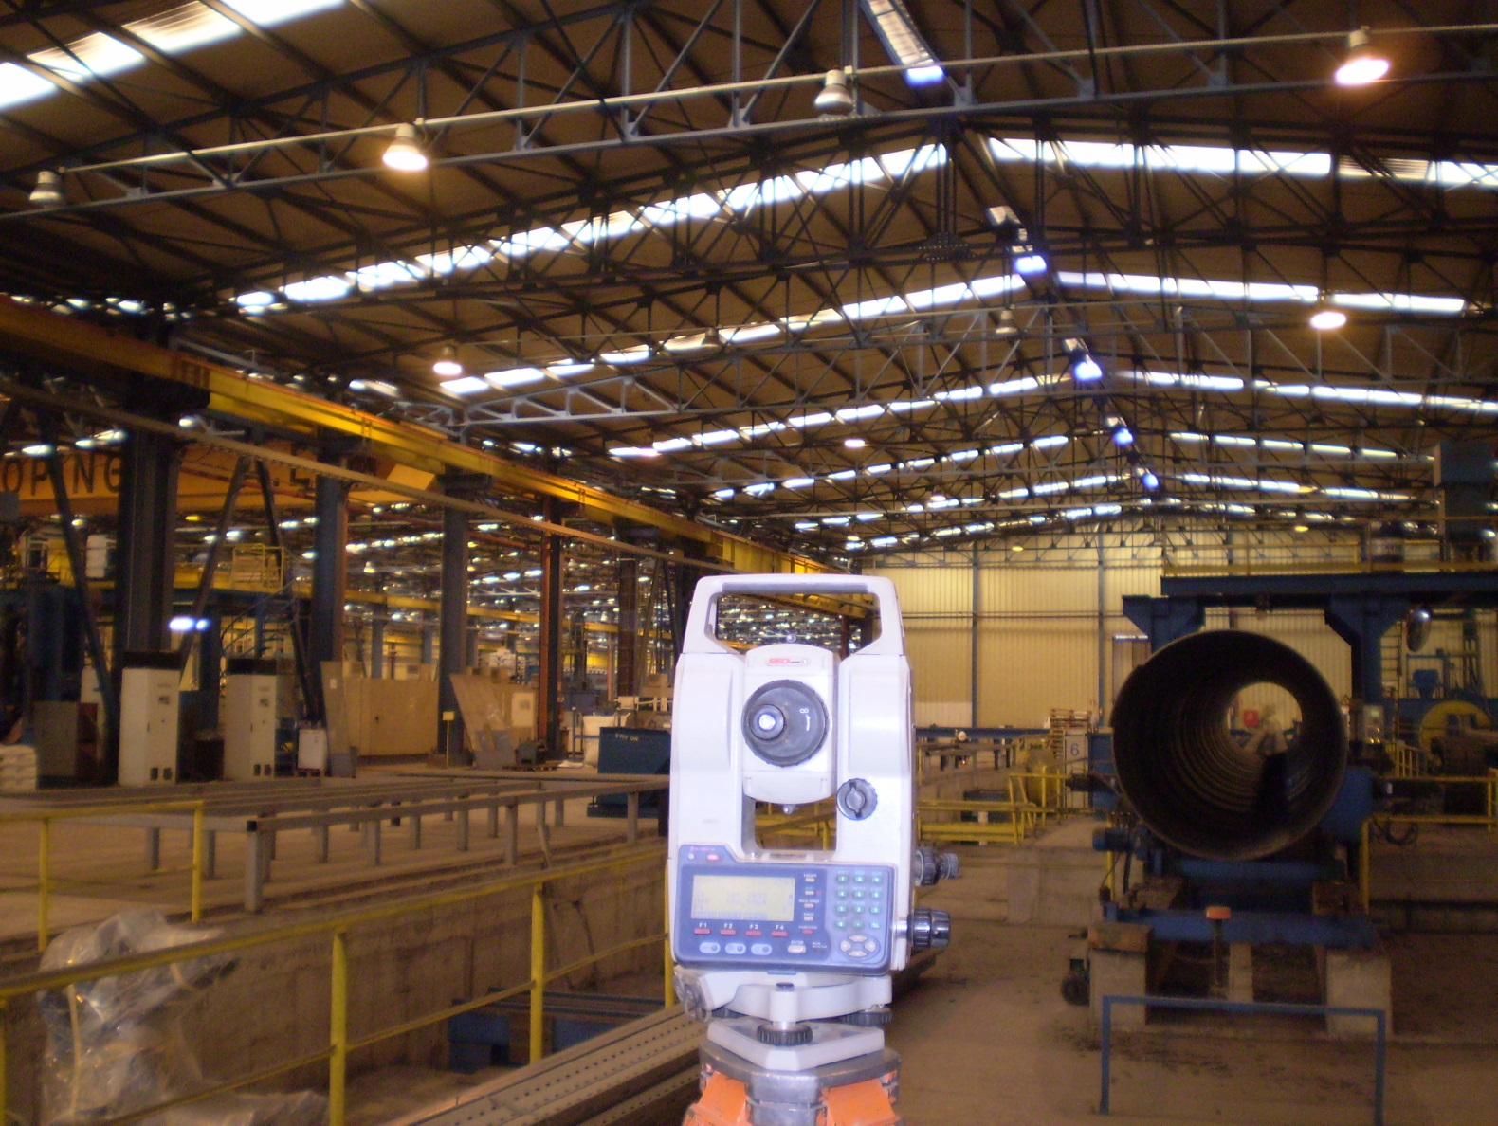

* Consulting on the financials, technical and operational requirements of each project.
* Working with the teams of subconstractors.
* Management of info & data flow between all of the involved parties.
* Performing all surveying works according to ISO standards.
* Undertaking of the whole project organization.
* Participating in all stages of construction starting from the initial design untik the final operation.
* Coordination of designs studies.
* Offering expert consulting services throughout the project by incorporating special surveying applications into our services.
* Providing accurate and updated field data to all designers.
* Documentation of quantity surveys.

Company’s Aims

Provision of consistent and dependable quality services.

Project delivery on time and within budget.

Meeting the needs of our clients on project basis.

www.aksm.gr

LASER SCANNING & BIM

7

5